Data Sheet
Product Information
Product Name | : | Recombinant Human Interleukin-7 (rhIL-7)
Synonyms | : | IL7, IL-7, interleukin 7,
Description | : | Interleukin 7 (IL-7) is a protein that in humans is encoded by the IL7 gene. IL-7 is a hematopoietic growth factor secreted by stromal cells in the bone marrow and thymus. It is also produced by keratinocytes, dendritic cells, hepatocytes, neurons, and epithelial cells, but is not produced by normal lymphocytes. IL-7 as an immunotherapy agent has been examined in many pre-clinical animal studies and more recently in human clinical trials for various malignancies and during HIV infection. (Ref. From Wikipedia)
NCBI Accession No. |  | NM_000880.3
Amino acid sequence | : | MFHVSFRYIFGLPPLILVLLPVASSDCDIEGKDGKQYESVLMVSIDQLLDSMKEIGSNCLNNEFNFFKRHICDANKEGMFLFRAARKLRQFLKMNSTGDFDLHLLKVSEGTTILLNCTGQVKGRKPAALGEAQPTKSLEENKSLKEQKKLNDLCFLKRLLQEIKTCWNKILMGTKEH
Molecular Mass | : | 17.48 kDa (153 aa)
Protein Tags | : | No tagging
Source | : | E. coli.
Cat. No. | : | JW-H019-0010, JW-H019-0025, JW-H019-0050, JW-H019-0100, JW-H019-0250, JW-H019-0500, JW-H019-1000
Storage | : | Should be at ≤ -70 ℃ as undiluted aliquots of handy size. Avoid repeated freezing and thawing.
Cross Reactivity | : | Human, Mouse Rat, Monkey, Pig

Quality Control
Test items |  |  |  | Specifications
Appearance |  |  | : |  | Clear, colorless liquid
Purity |  |  | : |  | Greater than 98 % by RP-HPLC and SDS-PAGE
Specificity |  |  | : |  | Using Western blot, detection | 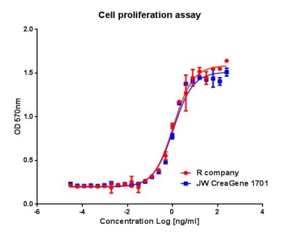
Concentration |  |  | : |  | 0.1 mg/㎖, Bradford method
Biological Activity |  |  | : |  | Determined by proliferation of 2E8 indicator cells.  The ED50 is <0.1 ng/ml, corresponding to a specific activity of > 1.0 × 10⁷ U/mg
Endotoxin |  |  | : |  | Less than 0.2 EU/㎍ as determined by the LAL method
Formulation |  |  | : |  | 30mM sodium citrate-citric acid, 10% glycerol (pH 5.0) without preservative or carrier proteins.
Stability |  |  | : |  | Stable for up to 12 months at -70 ℃. Stable for a month at 4 ℃.
Sterility |  |  | : |  | Sterilized through a 0.2 ㎛ membrane filter and packaged aseptically. Culture for 2 weeks, no growth

